WAD Assignment-1

Create a set of web pages that describe who you are. The home page for your site should contain the following information:

* About Me
  + Your name
  + Your email address (should be able to click to send an email)
  + Your major
  + A paragraph describing what you hope to gain from taking ISTA 230 this semester
  + A picture of yourself
  + A section of the page with space for links to future assignments

In addition to the home page, you should also have two other pages, **linked to from the home page**. Those pages are as follows:

* My Interests
  + You must include a heading and description of three different activities/hobbies that you enjoy
  + You must include a related image for each interest (feel free to get creative)
  + You must include a link to a related website or website entry (such as a Wikipedia page) for each interest
* My Favorite Song
  + You must include the song title of your favorite song
  + You must include the artist's name
  + You must include the lyrics of your favorite song
  + Artist's name should link to their home page (or related page such as the artist's Wikipedia entry)
* Both the "My Interests" and the "My Favorite Song" page should have a link back to your home page. **This link should use the text "<-- Return to the home page".**

Create a set of web pages that describe who you are. The home page for your site should contain the following information:

* About Me
  + Your name
  + Your email address (should be able to click to send an email)
  + Your major
  + A paragraph describing what you hope to gain from taking ISTA 230 this semester
  + A picture of yourself
  + A section of the page with space for links to future assignments

In addition to the home page, you should also have two other pages, **linked to from the home page**. Those pages are as follows:

* My Interests
  + You must include a heading and description of three different activities/hobbies that you enjoy
  + You must include a related image for each interest (feel free to get creative)
  + You must include a link to a related website or website entry (such as a Wikipedia page) for each interest
* My Favorite Song
  + You must include the song title of your favorite song
  + You must include the artist's name
  + You must include the lyrics of your favorite song
  + Artist's name should link to their home page (or related page such as the artist's Wikipedia entry)
* Both the "My Interests" and the "My Favorite Song" page should have a link back to your home page. **This link should use the text "<-- Return to the home page"**

Create a set of web pages that describe who you are. The home page for your site should contain the following information:

* About Me
  + Your name
  + Your email address (should be able to click to send an email)
  + Your major
  + A paragraph describing what you hope to gain from taking ISTA 230 this semester
  + A picture of yourself
  + A section of the page with space for links to future assignments

In addition to the home page, you should also have two other pages, **linked to from the home page**. Those pages are as follows:

* My Interests
  + You must include a heading and description of three different activities/hobbies that you enjoy
  + You must include a related image for each interest (feel free to get creative)
  + You must include a link to a related website or website entry (such as a Wikipedia page) for each interest
* My Favorite Song
  + You must include the song title of your favorite song
  + You must include the artist's name
  + You must include the lyrics of your favorite song
  + Artist's name should link to their home page (or related page such as the artist's Wikipedia entry)
* Both the "My Interests" and the "My Favorite Song" page should have a link back to your home page. **This link should use the text "<-- Return to the home page".**

Create a set of web pages that describe who you are. The home page for your site should contain the following information:

* About Me
  + Your name
  + Your email address (should be able to click to send an email)
  + Your major
  + A paragraph describing what you hope to gain from taking ISTA 230 this semester
  + A picture of yourself
  + A section of the page with space for links to future assignments

In addition to the home page, you should also have two other pages, **linked to from the home page**. Those pages are as follows:

* My Interests
  + You must include a heading and description of three different activities/hobbies that you enjoy
  + You must include a related image for each interest (feel free to get creative)
  + You must include a link to a related website or website entry (such as a Wikipedia page) for each interest
* My Favorite Song
  + You must include the song title of your favorite song
  + You must include the artist's name
  + You must include the lyrics of your favorite song
  + Artist's name should link to their home page (or related page such as the artist's Wikipedia entry)
* Both the "My Interests" and the "My Favorite Song" page should have a link back to your home page. **This link should use the text "<-- Return to the home page".**
* Appropriate use of HTML structures, including HTML tags and HTML entities
* Appropriate use of comments
* All HTML validates correctly *(remember, we're using XHTML 1.0 Strict, NOT HTML 5)*
* All links function as expected
* All images display properly

Output should be display like

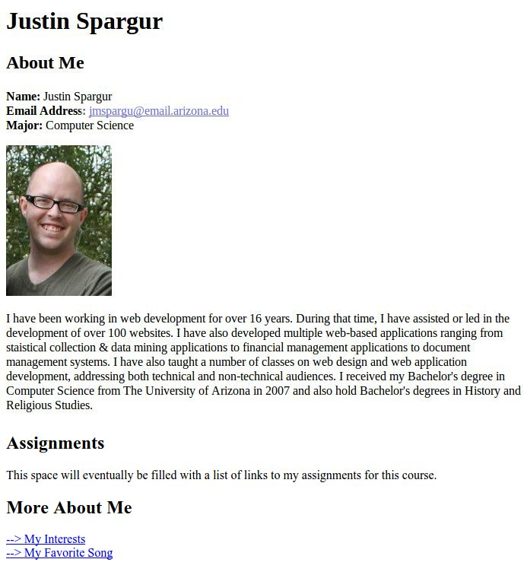

Second page

